Everyone wants to be healthy and strong. But how can be healthy and strong? Let me tell you！

**Good healthy to you!**



These are the advice for keeping healthy, follow these advice, you will be strong and healthy. At last, good healthy to you! May your Fat gets thinner.

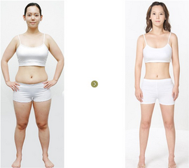

    Third please eat good food. Such us vegetables, fish, fruit. It can help you have a good body. such as fruit and vegetables, an apple a day keeps the doctor away. Eat less meat, don't eat Fried food. 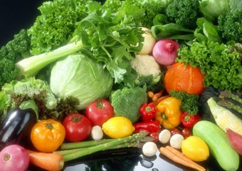

Second you must to do more exercises. Just like playing football, playing badminton and so on. It can make you strong. You must do exercise an hour once a day, It’s healthy and strong for you.



First you should have a good habit. You should go to bed early and get up early. It can make you healthy. And always brush your teeth. It can make your teeth strong.

