**First, we must have breakfast every morning. It’s good for our body . And make our body grow strong and strong…… But you must eat good food for your breakfast. Such as egg, vegetable, fruit, bread or some milk.**



**Third . Have good living habits. It’s good for we.Brush your teeth, eat good food ,wash your face. It’s good habits.**

**Now ,lets be a strong and healthy children .**

**First, ,we must have breakfast every morning. It’s good for our body . And make our body grow strong and strong…… But you must eat good food for your breakfast. Such as egg, vegetable, fruit, bread or some milk.**

**Second do exercise everyday. Such as swimming, running, walking , playing pingpong, playing basketball, playing volleyball,and football.it’s a very good news.**

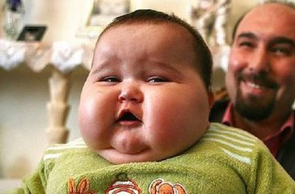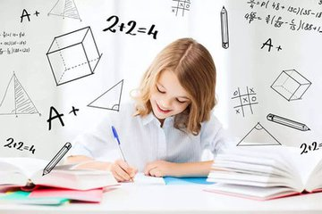

**Good health to you**

**Strong and healthy is very important for us. But how can we be strong and healthy ? It’s really easy!**