**Third , you need good living habits. For example,do not play computer game much time. go to bed early and get up early.It is good for you.**

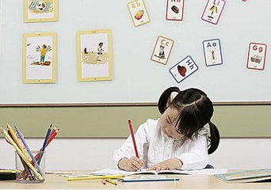

How to keep Healthy and Strong

六组

**Hello! We are healthy and strong.Do you want to be healthy and strong?OK.I will tell you how to keep healthy and strong.**

**Second,you need to do exercises every day.such as running swimming playing ping-pong•••••• It can make your body very strong.**



**At last, you need keep a happy mood everyday.**

**It is also good for you body. This it can make your body healthy and strong.**

**Fourth , you need work hard . you work hard at school at home and at sports.Lt is good for you.**



**First,you need eat healthy food.It is good to your body.Do not eat too much sweet food and fried food.It is bad for your body and teeth.**

